- Internship Name : Data Analysis
- Task Name: Task 3
- Learn Functions (def, Parameters, Return) and Core Data Structures: Lists, Tuples, and Dictionaries
- Your Name : Shubhangi Naresh Khonde
- Internship Organization :
- Date:

1.Objective:
The objective of this task was to understand and practice Python functions and basic data structures. The task focused on creating reusable functions using def, passing parameters, returning values, and working with Lists, Tuples, and Dictionaries.

2. Introduction:
Python provides functions and data structures that help programmers write organized, reusable, and efficient programs.
A function is a reusable block of code designed to perform a specific task. Functions can accept input through parameters and can return a result using the return statement.
Python also provides several built-in data structures. In this task, the following data structures were studied:
- Lists
- Tuples
- Dictionaries
These concepts are important for storing, managing, and processing data in Python applications and are especially useful in Data Analytics.
3.Concepts Covered:
Functions
A function is defined using the def keyword.
Basic syntax:
def function_name():
# statements
Functions can also accept parameters and return values.

Parameters
Parameters are variables passed to a function as input.
Example:
def greet(name):
print("Hello", name)

greet("Shubhangi")

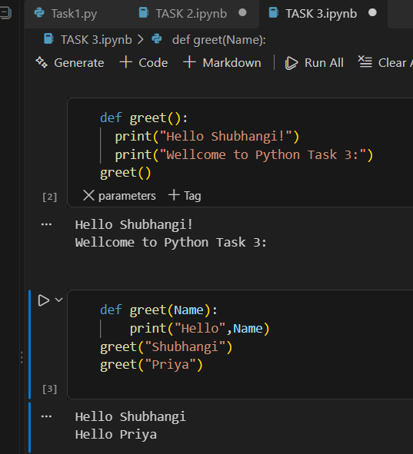

Return Statement:
The return statement sends a value back from the function.
Example:
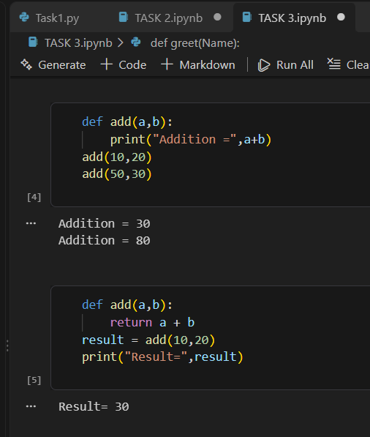

4. Lists:
A List is an ordered and mutable collection of elements. Lists can contain multiple values and can be modified after creation.
Example:
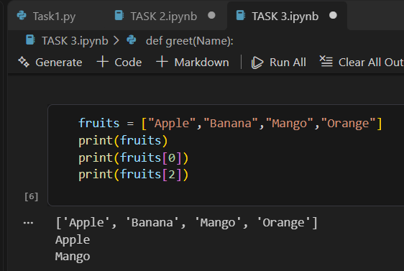

List elements can also be added or modified.
Example:
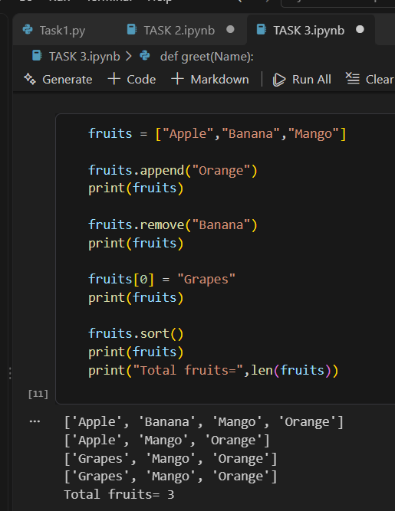

5.Tuples:
A Tuple is an ordered collection of elements that cannot be changed after creation. Therefore, tuples are called immutable.
Example:
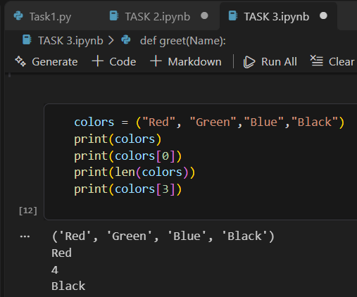

6.Dictionaries:
A Dictionary stores data in key-value pairs.
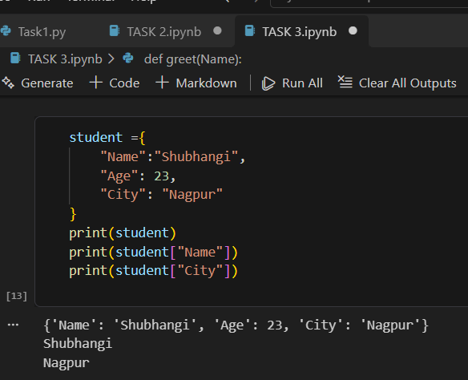

7.Results:
The task was successfully completed. The following concepts were practiced:
- Creating functions using def
- Passing parameters to functions
- Returning values using return
- Creating and modifying Lists
- Accessing List elements using indexes
- Creating and accessing Tuples
- Understanding immutable data
- Creating Dictionaries using key-value pairs

8. Key Learning:
Through this task, I learned how functions can be used to divide a program into smaller and reusable blocks of code. I also learned how parameters provide input to functions and how the return statement provides an output.
I learned the differences between Lists, Tuples, and Dictionaries and understood when each data structure can be used.

9. Conclusion:
This task provided practical knowledge of Python functions and core data structures. I successfully practiced functions with parameters and return values along with Lists, Tuples, and Dictionaries.The concepts learned in this task will provide a strong foundation for advanced Python programming and future Data Analytics tasks.

